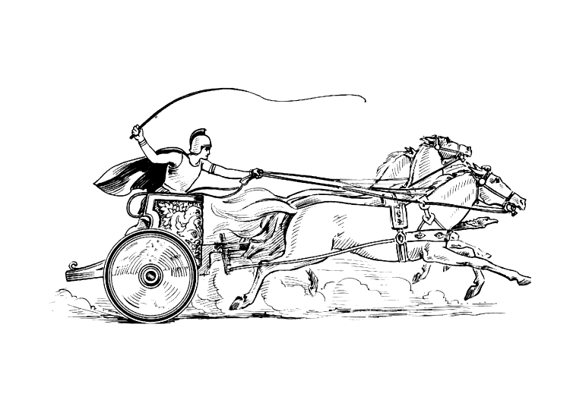 Manduessedum - Mancetter Village (Place of War Chariots)
Mancetter Parish Council
Serving the People of Mancetter and Ridge Lane

PARISH COUNCIL MEETING
OF THE PARISH OF MANCETTER

Minutes of the Parish Council Meeting of the Parish of Mancetter,
held on Tuesday 26th July 2022 at the Schoolroom
of St Peter’s Church Mancetter,
commencing at 7pm.

Present:
Chairman Mr T Hopkins.

Parish Councillors Mr H Blackburn, Mrs S Dore, Mrs G Forknall, Mrs S Healy and Mr P Mann.

County Councillor Mrs M Bell.
Borough Councillors Mrs D Clews.

Parish Clerk Mrs E Higgins.
Assistant Clerk Finance Mrs K Meads

Item 1 - Welcome and Apologies

Mr T Hopkins welcomed everyone to the meeting at 7pm.
A specialist portable air filtration system was plugged in throughout the meeting to provide covid ventilation
as usual.

Apologies were received from Mrs N Wallis due to annual leave and Mr A Clews due to work commitments.
These apologies were accepted.

Item 2 – Recording of the meeting.

There was no recording of the meeting.

Item 3 – Notice of Interest.

During the discussion on item 11c relating to signage within the cemetery, Mr P Mann declared a non – pecuniary interest in the company being asked to quote, by nature of a family connection.

Item 4 – Public Question Time.

There were no members of the public present, and no issues had been raised with the Clerk prior to the meeting.

Item 5 – Minutes of the last meeting.

The draft minutes from the 24th May 2022 were agreed unanimously by those present at the meeting, and therefore formally signed by the chairman as a true record of proceedings.

Rather than read through the minutes from the Annual Meeting of Parishioners at this meeting, it was agreed to go through them in the summary of parish business at the informal parish gathering / possible jubilee charity auction on 21st September 2022.

Item 6 – Matters arising from the previous minutes.

- Update on Community Speed Watch

The Mancetter Speed Watch Group have now been out independently for three monitoring sessions on Nuneaton Road at different days and times. A further site along Manor Road has also been approved for monitoring by PC Simon Ackroyd who is one of the officers in charge of supporting the speed watch programme.

Over these sessions 26 vehicles were recorded and verified by the Speed Gun in excess of 35 miles per hour in a 30-mph zone. The drivers concerned will be receiving a letter from the Police highlighting the issue and repeat offenders can expect action to be taken.

- Review of Mancetter Parish Jubilee Celebrations: Proposed Charity Auction and Allocation of Prizes.

A date will be set for a team of Councillors and the Clerk to independently award prizes for different categories of Jubilee shield decoration across both villages. It is provisionally proposed to hold Charity Auctions in Mancetter on the 21st September and at Ridge Lane on the 23rd, but these dates will need to be confirmed.

- NWBC Draft Climate Change Action Plan.

Parish Councillor Sue Healy shared some of the points that could be raised by the Parish Council in response to the consultation questions. Councillor Healy will liaise with the Clerk and the response collated.

Items 7& 8– Feedback from Police, Borough and County Councillors.

There was no Police report or attendance at this meeting.

County Council

Graham Stanley from County Highways is available to set up another site visit during August to agree locations for the two VAR signs and additional portable brackets. Mrs E Higgins will look to co-ordinate some meeting dates.

Trevor Hopkins raised with Margaret Bell the ongoing problems the Parish Council has encountered with Footpath Way Markers and lack of maintenance of the footbridge across the River Anker at the bottom of Mill Lane. Margaret will speak to one of the heads of department and get some feedback about the issues.

Borough Council

Borough Councillor Denise Clews updated the council on the continued lack of enforcement capability due to the resources being allocated to the Travellers site at Kirby Glebe Farm.

The Parish Council will seek advice from Historic England regarding the situation adjacent to the scheduled ancient monument site in the centre of Mancetter village.

The recent flattening of an access gate into Mancetter Recreation Ground, by some youths riding a dumper truck was discussed, and Parish Councillor Harry Blackburn would like to be involved in considering the options for the replacement.

Item 9- Finance

- Two councillors signed the financial paperwork since the last meeting in accordance with Standing Orders and the Bank Mandate.
- A financial report showing the income and expenditure against budget for the first quarter of the year had been issued to councillors prior to the meeting and no issues have been highlighted.

Item 10- Planning Matters and New Applications. Update on recent applications, enforcement issues
and determinations from planning lists.

Enforcement concerns had been covered within the Borough Council update, and Councillor Clews will pass on to Planning, photographs and observations concerning retrospective planning applications within the developments on the former Stoneleigh Quarry Farm site.

Planning determinations were noted and no objections raised concerning the conservatory in Tom Piper Close Ridge Lane.

The proposal to divert Bridleway AE109X has been received positively by members of the public who would like to see the continuation of the path right up to the top of the hill to maximise the scenic views. The Quarry had been particularly helpful in explaining the rationale, and positive feedback will be given to the Rights of Way Team at the County Council.

Item 11– Cemetery and Maintenance around the Parish.

- The new Cemetery Deed book is now stored within the document safe.
- It was agreed unanimously by Councillors to open the Jubilee Avenue for the Scattering of Cremated Remains. An entry will be made in the records and be subject to an administration fee. No commemoration plaques will be allowed within the area.
- Nuneaton Signs will be asked to quote for a “Georgian Style Street Sign” to mark the entrance to the avenue of trees. Advice will be sought from the Heritage Officer at the Borough Council due to being situated within the conservation area. Funding could possibly be taken from the balance of the Platinum Jubilee Reserve.
- The Parish Council resolved to allow a discount of up to 30% for non- parishioners who have spent many years in public service within the parish. This will have to be considered on a case-by-case basis.

Item 12 - Dates of next meetings:

Informal Meeting with Parishioners and possible Jubilee Charity Auction Wednesday 21st September 2022 7pm at Mancetter Memorial Hall.

Parish Council Meeting Tuesday 27th September 7pm in the Schoolroom, St Peter’s Church Mancetter.

As there was no further business the meeting closed at 9.30pm
Manduessedum - Mancetter Village
(Place of War Chariots)
Mancetter Parish Council
Serving the People of Mancetter and Ridge Lane

